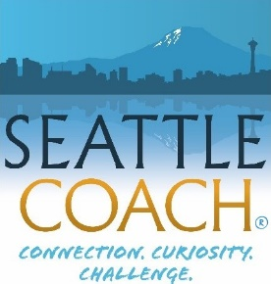
Patricia Burgin, MA, MCC
SeattleCoach LLC
www.seattlecoach.com
The SeattleCoach Professional Training & Development Program (ACSTH)
2727 Fairview Ave East Suite F
Seattle, WA 98102
206.412.6224

Module III Advanced Training Modules in 2024
Coaching Groups and Teams

Each Module III team is a unique collaboration. If you have completed Modules I and II and think you might want to join us, please review the Module III page, and then write down your thoughts about the following questions. Then keep a copy and send one to the team who will be your facilitators.

Your Contact Info

Your name

Your mailing address

City Zip

Best e-mail address

Best phone number for calling/texting you Today’s Date

A Few Questions for You

- When you think of our tag line, “doing the craft, being the coach,”
  - In all SeattleCoach Module IIIs we deepen the connection between Key Skills and the Core Competencies—both in your work with individuals and with groups and teams. What is a Core Competency you’d like to better understand and refine?

  - What are some ways in which you want to understand and use your own life and style even more?

- What piques your interest in learning to coach Groups and Teams?

- Why now?

- When the course is finished, what do you want to have in place?

- Are you currently coaching any groups and/or teams?

- Course fee: The details and payment links are right here. (There’s a discount if you pay before January 31, 2024.

- Upon completion of this course, you will be credited with 40 coach-specific training hours.

- If you expanded your visibility and relationships (public identity and trust) as a coach in the coming year, how do you think you’d do it? (Workshops? Web presence? Writing? Lots of really good work? Etc.)

- What is your vision for the professional development of your coaching in the coming year? For your professional credentialling?

- What will be one of your major contributions to this team? What will you help us to get better at?

The Usual SeattleCoach Agreements . . .
- Your monthly presence in our sessions is a big deal. OK with you? Initial here

- Peer coaching with other coaches. You’ll be able to add these hours to your “bartered/paid” log. This too is a big deal. OK with you? Initial here

- The third factor is the full hour between each session of independent study and reflection. We call this “RPRP”—Review and Practice / Read and Prepare. We’ll send you pages to read, videos to watch, and questions to reflect on. Your time in independent study is also required. OK with you? Initial here
SeattleCoach Module IIIs have been approved by the ICF for additional coach-specific training (CCEs).
That’s it! Please send a copy of this agreement to Sue Couper and John LaMunyon. And thanks for the thoughtfulness with which you’ve reviewed our questions. We’re excited to have you on board.

